1 PERSONAL PARTICULARS
Name:
Address:
Contact no.:

Personal email:

Work email:

2 EDUCATIONAL AND PROFESSIONAL QUALIFICATIONS
Please include qualifications and certifications specific to the area of specialisation applied for.
Month/Year | Qualification / Certification Area

3 SPECIALTY TRAINING PROGRAMME

Month/Year | Programme

In the following sections 4-9, the applicant should provide evidence of personal contributions and achievements that are relevant to the specialty practice (refer to the activities described in the “Pharmacy Specialist’s Scope of Practice” document in Appendix 1 and “Evaluation Guidance for Specialist Practice Scope at Entry Level” document in Appendix 2). For sections 4-9, the applicant should tabulate the information in his/her CV under “Month/Year/Role” and “Activities”.

4 DOMAIN 1: EXPERT PROFESSIONAL PRACTICE

In this section, applicant must demonstrate that he/she possesses the knowledge, skills and competencies of a specialist in the specialty that the applicant is applying to be accredited. Applicant should set in detail his/her clinical practice including his/her job scope/description, involvement in institutional or national committees

- Applicant must practise at least 8 hours per week (20% of clinical practice hours) in
SPECIALTY for the past 3 years.

- Applicant must provide details on how he/she has personally made contributions to patients’ pharmacotherapy, in chronological order, and organised in accordance to each institution/department one has worked in. The following details are required of the applicant:

- Clinical and Service Provision Roles, including but not limited to ward rounds, clinical service provision within a specialised service team or clinic, etc. Please provide a write up with the following contents:
  - A description of the nature of the service and scope of work covered.
  - Work load data (e.g. number of hours spent per case, number of cases covered per week).
  - Documented evidence of your role(s) and contribution to the team, e.g. Drug Profile or Monograph prepared for the Pharmacy & Therapeutics Committee review.

Note 1: For each competency standards, applicant may submit up to 3 recent and relevant evidence examples only.
Note 2: For separate annexes submitted for consideration, please name the files with reference to the competency standards submitted for (e.g. Standard 1.1 – description of content).

Competency Standards | Details in Chronological Order
Standard 1.1
Demonstrates Expert Skills and Knowledge.

Advanced Level
- Demonstrates advanced pharmaceutical knowledge in a defined area(s).
- Is able to plan, manage, monitor, advise and review pharmaceutical care programmes for patients in a defined area(s).

Standard 1.2
Manages Patient Care Responsibilities/ Delivery of Professional Activities.

Advanced Level
- Is accountable for the delivery of a pharmacy service to a defined group of patients.
- The delivery of pharmacy service would be for specialty patients.
- The applicant should be able to lead a QI project but does not need to be at the managerial level.

Standard 1.3
Exhibits Reasoning and Judgement including Analytical Skills, Judgmental Skills, Interpersonal Skills and Appraisal of Option.

Advanced Level
- Demonstrates ability to use skills to make decisions in complex situations where there are several factors that require analysis, interpretation and comparison.
- Demonstrates an ability to see situations holistically.

Standard 1.4
Uses Professional Autonomy.

Advanced Level
- Is able to take action based on own interpretation of broad professional policies/ procedures where necessary.

5 DOMAIN 2: BUILDING OF PROFESSIONAL RELATIONSHIPS

- Applicant must provide details on how he/she has made contributions, in chronological order, organised in accordance to each appointment. The following details are required of the applicant:

- Appointment held, including scope of work and contributions.
- List specific examples of how he/she contributed to the achievements of the committee/workgroup to which he/she was appointed.

Note 1: For each competency standards, applicant may submit up to 3 recent and relevant evidence examples only.
Note 2: For separate annexes submitted for consideration, please name the files with reference to the competency standards submitted for (e.g. Standard 2.1 – description of content).

Competency Standards | Details in Chronological Order
Standard 2.1
Ability to Communicate Effectively (Communication).

Advanced Level
- Demonstrates use of appropriately selected communication skills to gain co-operation of small groups of patients, caregivers, colleagues, senior clinicians and managers within the organisation.

- Demonstrates ability to communicate where the content of the discussion is based on opinion.

Standard 2.2
Collaborates with Members of the Health Care Team and Offer Consultations (Teamwork and Consultation)

Advanced Level
- Demonstrates ability to work as an acknowledged member of a multidisciplinary team.
- Accepts consultation for specialist advice from within the organisation.

- DOMAIN 3: LEADERSHIP

- Applicant should be a Lead or Co-lead in at least one CQI project completed in the last 7 years preceding the specialist accreditation application.

- Leadership and Committee Roles, including but not limited to his/her direct contribution to the team on the following:
- Key Performance Indicators or Key Performance Areas.
- Achievements in the form of team awards or other form of official recognition.
- Where applicable, policies or protocols authored, reflection logs of practice by self.

Note 1: For each competency standards, applicant may submit up to 3 recent and relevant evidence examples only.
Note 2: For separate annexes submitted for consideration, please name the files with reference to the competency standards submitted for (e.g. Standard 3.1 – description of content).

Competency Standards | Details in Chronological Order
Standard 3.1
Creates Vision

Advanced Level
- Embraces the vision and translates this into clear directions for staff and management.

Standard 3.2
Strategic Planning

Advanced Level
- Demonstrates understanding of culture, climate and needs of stakeholders both internal and external; and the ability to incorporate national healthcare policy which influences departmental / institutional strategy.
- Demonstrates ability to plan over a year ahead within a defined area.

Standard 3.3
Innovation in Specialty

Advanced Level
- Recognises and implements innovation independently.

Standard 3.4
Motivates Individual (Motivational)

Advanced Level
- Demonstrates ability to motivate individuals in the team.

7 DOMAIN 4: MANAGEMENT

- Leadership and Committee Roles, including but not limited to his/her direct contribution to the team on the following:
- Key Performance Indicators or Key Performance Areas.
- Achievements in the form of team awards or other form of official recognition.
- Where applicable, policies or protocols authored, reflection logs of practice by self.

Note 1: For each competency standards, applicant may submit up to 3 recent and relevant evidence examples only.
Note 2: For separate annexes submitted for consideration, please name the files with reference to the competency standards submitted for (e.g. Standard 4.1 – description of content).

Competency Standards | Details in Chronological Order
Standard 4.1
Implementing Organisational Priorities

Advanced Level
- Shapes the response of the team to achieve organisational priorities.

Standard 4.2
Managing Resource Utilisation

Advanced Level
- Demonstrates ability to effectively manage resources.

Standard 4.3
Establishing Standards of Practice

Advanced Level
- Accountable for the setting of targets and monitoring of standards of practice.

Standard 4.4
Managing Risk

Advanced Level
- Is accountable for developing risk management policies/ protocols for the team, including identifying and resolving new risk management issues.

Standard 4.5
Managing Performance

Advanced Level
- Is accountable for performance management for the team.

Standard 4.6
Project Management

Advanced Level
- Demonstrates ability to successfully manage a project at team level.

Standard 4.7
Managing Change

Advanced Level
- Demonstrates ability to manage a process of change for the team.

8 DOMAIN 5: EDUCATION, TRAINING AND DEVELOPMENT

In this section, applicant shall set out in detail the types of education, training and/or professional development programmes that he/she provides to other healthcare professionals, students, patients and public in the specialty that the applicant is applying to be accredited for.

- Applicant shall describe his/her involvement in these programmes, including the role, frequency and duration of participation.

- Applicant must provide details on how he/she has made contributions, in chronological order, organised in accordance to each appointment or institution. The following details are required of the applicant:

- Appointment held, including scope of work and contributions.
- List specific examples of how he/she contributed to the formal clinical training programmes.
- Number of trainees and/or hours spent in the activities should be furnished.
- List specific examples of how he/she contributed to the leadership role for clinical education or training programmes, e.g. residency programme directorship.

- Applicant must provide details on how he/she has made contributions, in chronological order, organised in accordance to each presentation, certificate programs, short courses, workshops, in-service lectures. The following details are required of the applicant:

- Title, Date (Month/Year), Event or Name of organiser.
- Frequency (e.g. how many times per year or once-off).
- Target audience and size.

Note 1: For each competency standards, applicant may submit up to 3 recent and relevant evidence examples only.
Note 2: For separate annexes submitted for consideration, please name the files with reference to the competency standards submitted for (e.g. Standard 5.1 – description of content).

Competency Standards | Details in Chronological Order
Standard 5.1
Role Model

Intermediate Level
- Understands and demonstrates the characteristics of a role model to members of the team.

Standard 5.2
Mentorship

Intermediate Level
- Demonstrates understanding of the mentorship process.

Standard 5.3
Conducting Education and Training

Intermediate Level
- Demonstrates self-development through routine Continuing Professional Development activity with facilitation.
- Demonstrates ability to conduct teaching efficiently according to a lesson plan with supervision from a more experienced colleague.

9 DOMAIN 6: RESEARCH AND EVALUATION

In this section, applicant shall set out in detail his/her research contributions to the specialty
that the applicant is applying to be accredited for.

- Applicant should initiate or collaborate in research.
- Applicant should present results of research in <SPECIALTY> at national or international scientific meetings and/or publishes peer-reviewed reports of original research in <SPECIALTY>.
- Minimum of 3 posters, oral research presentations or publications in the 7 years preceding application. No encore presentation is allowed.

Note: Points (a) and (b) should be specialty specific. Point (c) need not be speciality specific.
- Applicants should include as many pieces of work specific to their area of specialty as possible, and provide synopsis or content for i), iii) and iv). For i) to iii), please list all authors and underline applicant’s name for the purpose of identification of order of contribution.

The following details are required for Publications (Original Investigations and Review Articles), Poster/Oral Presentations, Publications (Book Chapter) and Journal Reviewer:

- Forum and intended audience: National or international scientific meetings;
- Publications in peer-reviewed journals (to list citations), posters for meetings or conferences;
- Research grants awarded for his/her research; and
- Contribution as a reviewer or editor for scientific/professional publications, or invited reviewer for grant applications.

Note 1: For each competency standards, applicant may submit up to 3 recent and relevant evidence examples only.
Note 2: For separate annexes submitted for consideration, please name the files with reference to the competency standards submitted for (e.g. Standard 6.1 – description of content).

Competency Standards | Details in Chronological Order
Standard 6.1
Evaluating Literature Critically and Identifying Evidence Gaps

Advanced Level
- Demonstrates ability to critically evaluate, review medical literature, and identify evidence gaps and to apply evidence-based practice at departmental/ institutional level.

Standard 6.2
Developing and Evaluating Research Protocols

Advanced Level
- Demonstrates ability to lead in the development and conduct of a research.

Standard 6.3
Disseminating Evidence

Advanced Level
- Demonstrates ability to generate new evidence accepted for presentation at research symposia (e.g. conferences, seminars or forums) or publication.

Standard 6.4
Guiding Others Undertaking Research

Intermediate Level
- Is aware of the research activities within the department and is able to provide guidance on research methodology.

Standard 6.5
Establishing Research Partnerships

Intermediate Level
- Demonstrates ability to work as a member of a project team.

No. | Title of Study | Mode of Presentation (Poster/Oral Presentations) | Role  Note:  - Please indicate if you are the primary author.  - If not, please indicate your role of contribution to the study

No. | Research Grants Project Title | Funding Amount | Funding Agency | Role | Month/Date

10 OTHERS
In this section, the applicant may wish to provide details on any awards which he/she has received, and other significant contributions made to the specialty.

No. | Award Title | Role | Date

Appendix 1
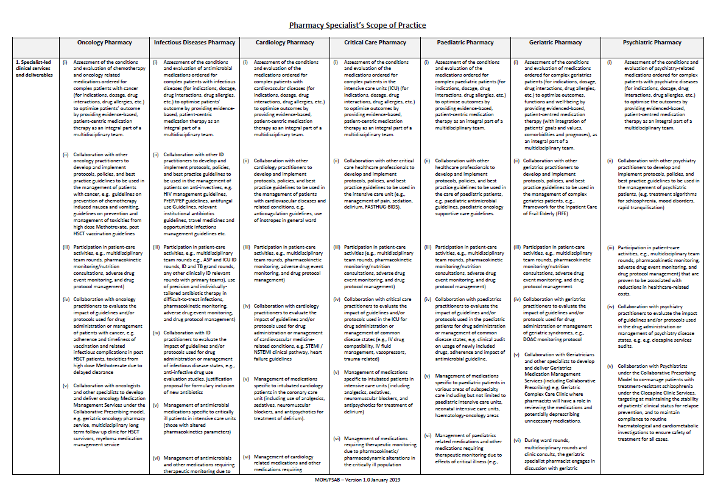

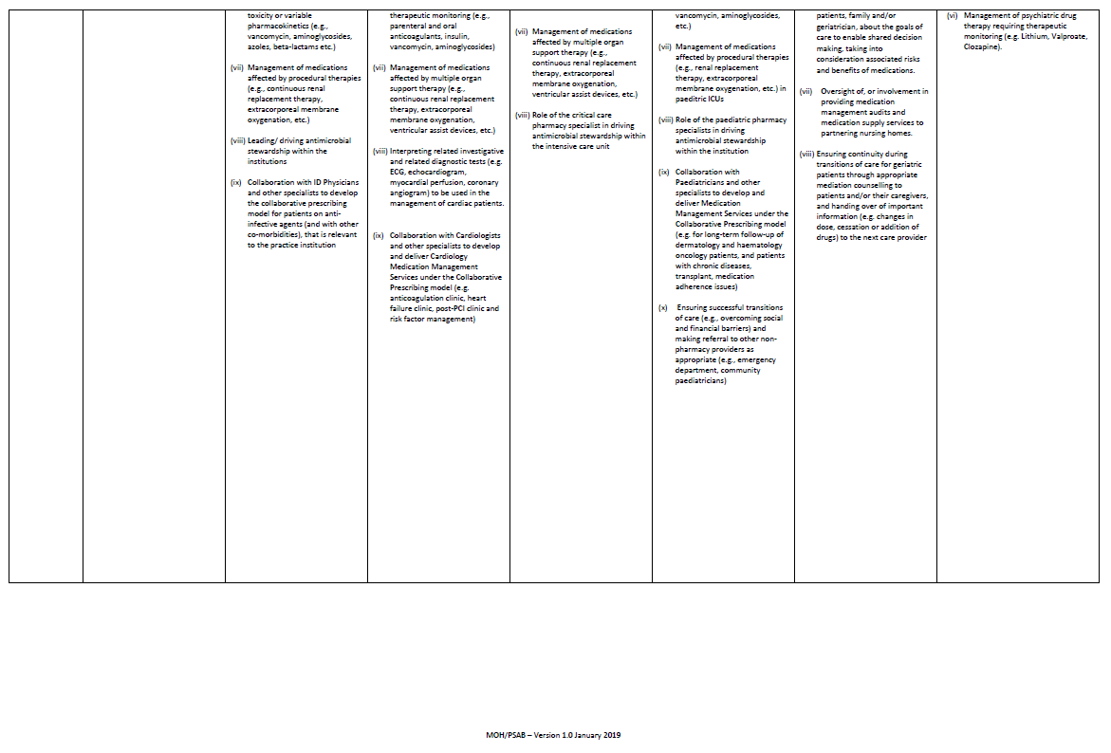

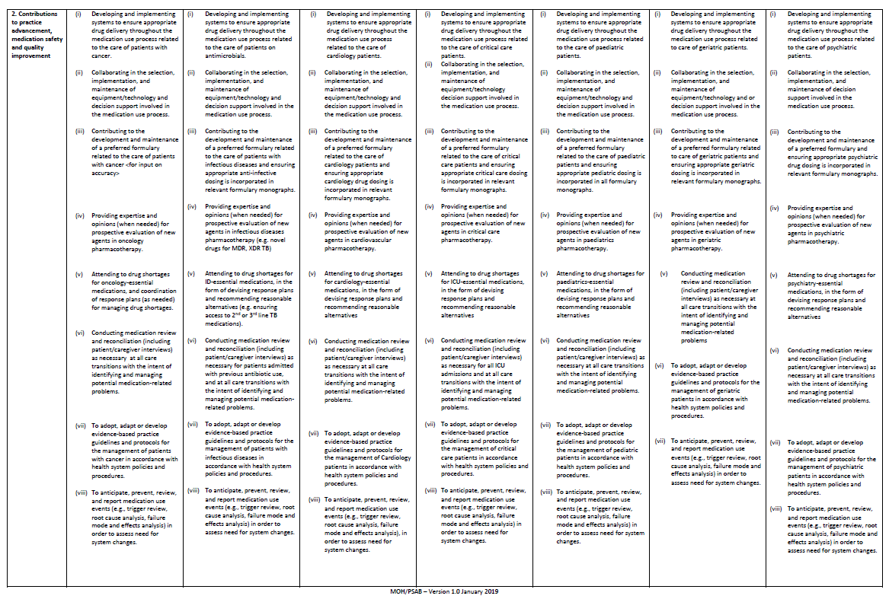

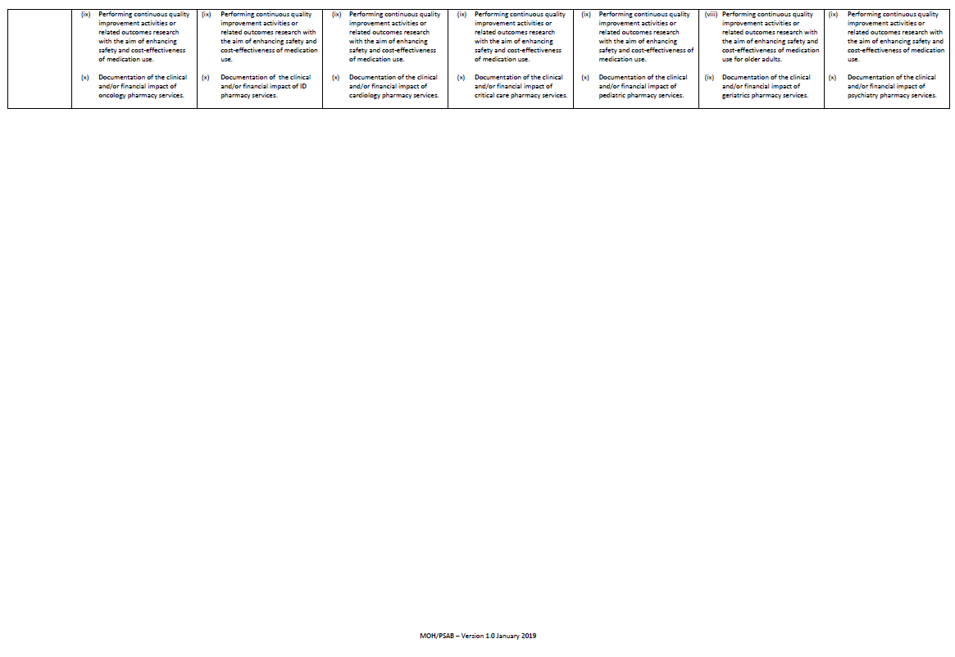

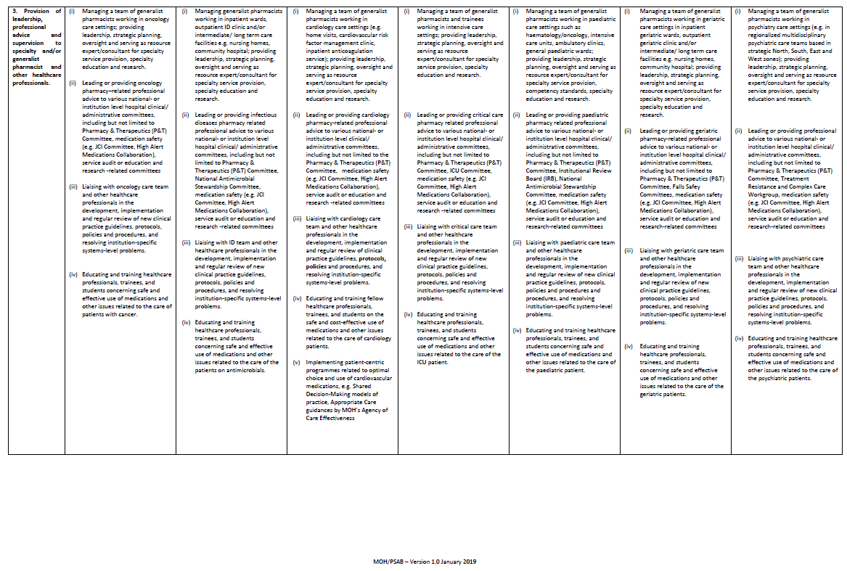

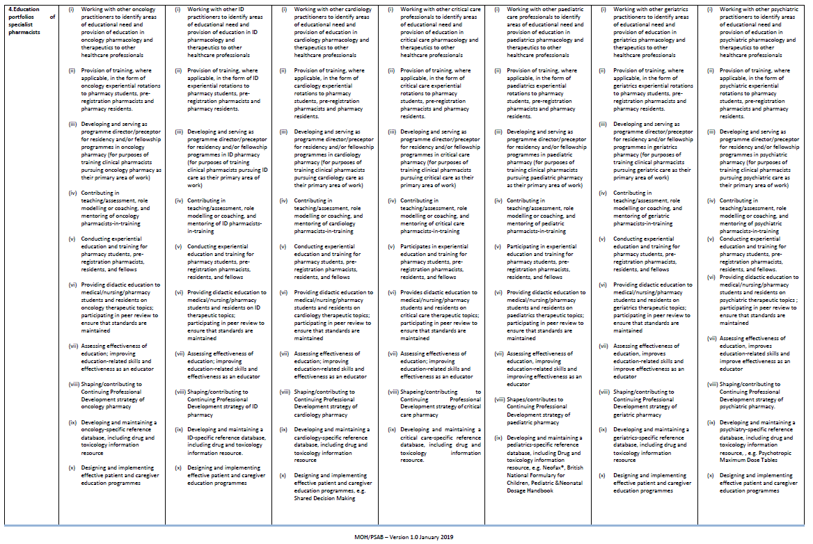

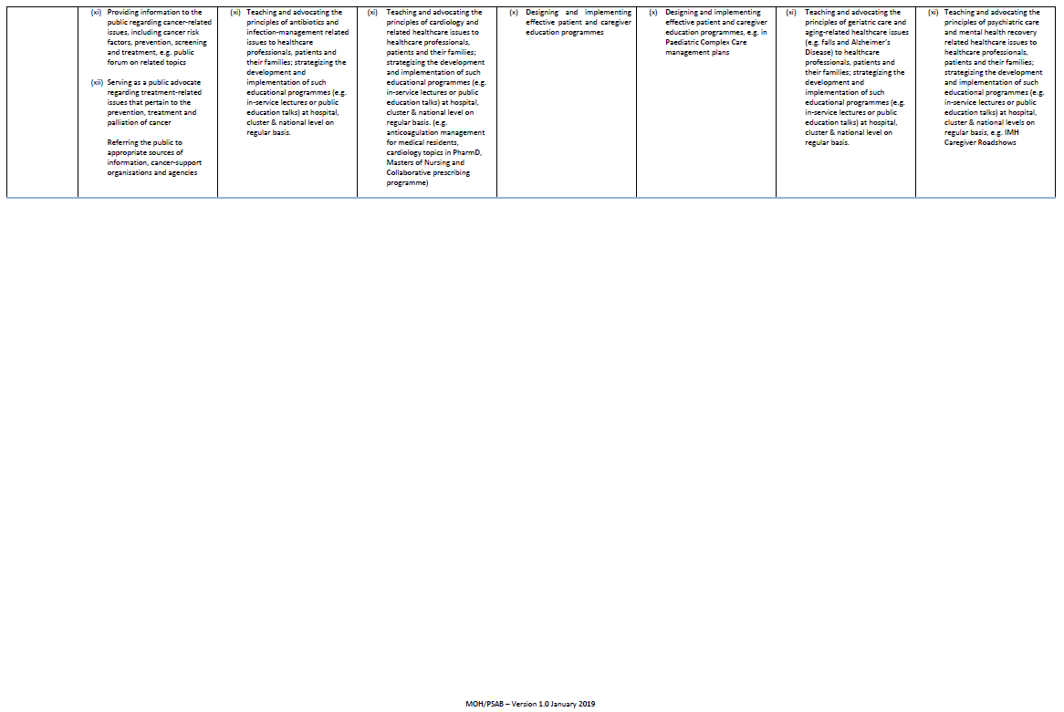

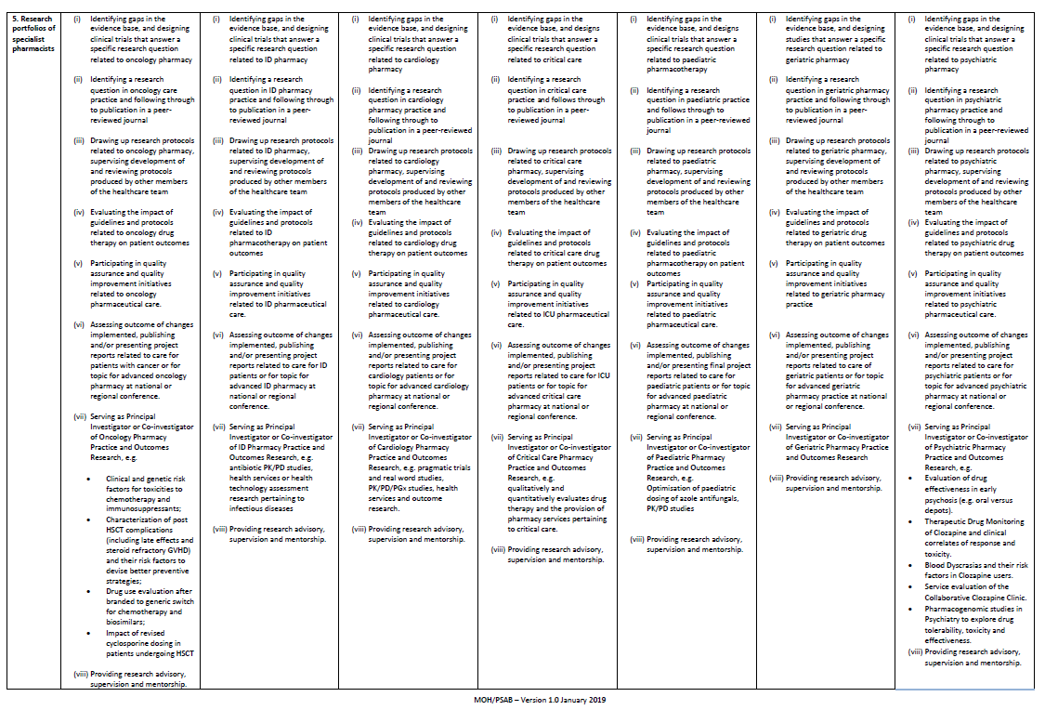

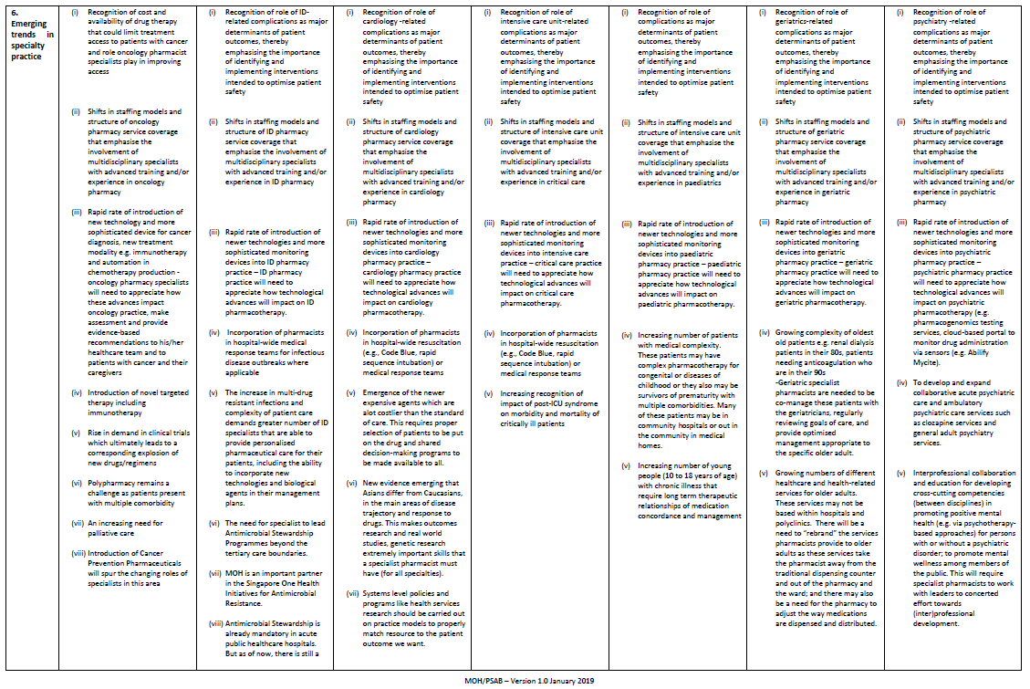

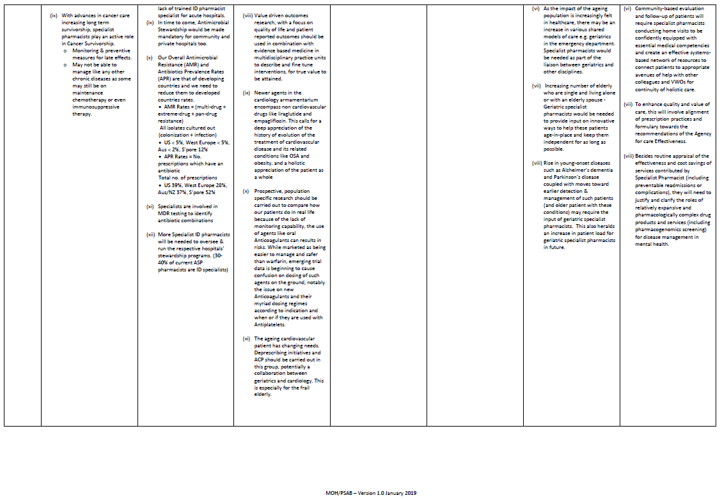

Appendix 2
Evaluation Guidance for Specialist Practice Scope at Entry Level
Assessment Domains and Competency Standards Aligned to the Development Framework for Pharmacists (DFP) Standards. |  | Performance Levels  (Mapped to DFP)
Domain 1: Expert Professional Practice
- Applicant must practise at least 8 hours per week (20% of clinical practice hours) in SPECIALTY for the past 3 years.

1. | Standard 1.1  Demonstrates Expert Skills and Knowledge | Advanced Level  - Demonstrates advanced pharmaceutical knowledge in a defined area(s).  - Is able to plan, manage, monitor, advise and review pharmaceutical care programmes for patients in a defined area(s).  Evidence:  - Regarded as a source of expertise for the management of patients with drug-related problems related to specific disease states.  - Able to accurately and efficiently identify multiple, complex drug-related problems and develop therapeutic plans through evidence-based knowledge and experience in a defined field of practice.  Evidence examples:  - Documented pharmacy interventions and enquiries e.g. requests from other healthcare professionals or patients.  - Documented pharmaceutical care plans in complex cases.
2. | Standard 1.2  Manages Patient Care Responsibilities/ Delivery of Professional Activities | Advanced Level  - Is accountable for the delivery of a pharmacy service to a defined group of patients.  - The delivery of pharmacy service would be for specialty patients.  - The applicant should be able to lead a QI project but does not need to be at the managerial level.  Evidence:  - Able to provide safe, effective and timely pharmaceutical care to a defined group of patients with special needs or in a defined service area  - Able to adopt a person-centered approach to facilitate continuity of care.  - Able to collate and analyse data for improvement opportunities  Evidence examples:  - Achievement of Key Performance Indicators (KPIs) as Manager of a section.  - Contribution as Leader of a Quality Improvement project for care delivery to a defined group of patients e.g. patients in Anticoagulation clinic, Hypertension-Diabetes-Lipid clinic.  - Documentation of how Plan-Do-Check-Act (PDCA) cycle is applied to service delivery.
3. | Standard 1.3  Exhibits Reasoning and Judgement including Analytical Skills, Judgmental Skills, Interpersonal Skills and Appraisal of Option | Advanced Level  - Demonstrates ability to use skills to make decisions in complex situations where there are several factors that require analysis, interpretation and comparison.  - Demonstrates an ability to see situations holistically.  Evidence:  - Able to make practical and effective decisions in a timely fashion, in complex situations.  - Able to ask pertinent questions, list and evaluate options by constructing best and worst scenarios, and assess chances of success and consequences or failure.  - Able to discuss and communicate these plans with team members and stakeholders effectively.  Evidence examples:  - Contribution as a member of institutional committee e.g. clinical governance committee.  - Feedback from: Peers/ colleagues; Supervisor/ tutors; Team members; Learner/ trainees.  - Examples of documented interventions done.  - Reports of medication errors investigated.  - Documented evidence of problem/ issue resolution when handling difficult customers with complex needs.  - Role in the revision or development of departmental/ institutional guidelines/ protocols.
4. | Standard 1.4  Uses Professional Autonomy | Advanced Level  - Is able to take action based on own interpretation of broad professional policies/ procedures where necessary.  Evidence:  - Able to decide on a course of action in an ambiguous situation or in the absence of specific policy/procedure.  Evidence examples:  - Role in the initiation of a new service which has no precedence e.g. telepharmacy even when the law has no provision for it.  - Documented actions taken in situations requiring ethical considerations.
Domain 2: Building of Professional Relationships

5. | Standard 2.1  Ability to Communicate Effectively (Communication) | Advanced Level  - Demonstrates use of appropriately selected communication skills to gain co-operation of small groups of patients, caregivers, colleagues, senior clinicians and managers within the organisation.  - Demonstrates ability to communicate where the content of the discussion is based on opinion.  Evidence  - Able to communicate with patients, caregivers and colleagues both within and outside of the Department and show the ability to persuade, motivate and collaborate.  - Able to communicate effectively with small groups both within and outside the department through presentation/ talk/ meeting with minimal guidance.  - Able to deal with difficult situations where communication is required e.g. managing difficult situations and diffusing conflicts.  Evidence Examples  - Feedback from: 360-degree evaluation; Observational feedback from colleagues both within and outside department; Patients; Trainees' evaluation.  - Written communication by the individual e.g. correspondences, articles.  - Presentation materials and audience feedback.  - Evidence of collaboration with colleagues from other departments through projects/ workgroups, etc.
6. | Standard 2.2  Collaborates with Members of the Health Care Team and Offer Consultations (Teamwork and Consultation) | Advanced Level  - Demonstrates ability to work as an acknowledged member of a multidisciplinary team.  - Accepts consultation for specialist advice from within the organisation.  Evidence  - Able to respond to the demands and expectations of members of the health care team.  - Able to share information and expertise to facilitate a common understanding.  - Able to maintain rapport and work in partnership (share information with patient's consent, and work cooperatively on patient's health goals) with other healthcare professionals to achieve therapeutic goals.  - Able to be actively contributing a pharmacist's perspective and make a positive contribution to team-based problem solving and decision making.  Evidence Examples  - Peer review through 360 degree feedback.  - Observational feedback from colleagues both within and outside department.  - Achievement of team-based outcomes or participation in defining the outcomes to be achieved by the department.  - Contribution as a member in workgroups/ committees, at organisation level.
Domain 3: Leadership

- Candidates should be a Lead or Co-lead in at least one clinical quality improvement (CQI) project completed in the last 7 years preceding the specialist accreditation application.

7. | Standard 3.1  Creates Vision | Advanced Level  - Embraces the vision and translates this into clear directions for staff and management.  Evidence  - Able to communicate department and corporate visions to staff and conceptualise them into action plans for the section/department.  Evidence Examples  - Examples of how the vision is translated into strategies and actions for the team.  - Workplan and targets developed for team/ section is in alignment with the department/ hospital’s vision.
8. | Standard 3.2  Strategic Planning | Advanced Level  - Demonstrates understanding of culture, climate and needs of stakeholders both internal and external; and the ability to incorporate national healthcare policy which influences departmental / institutional strategy.  - Demonstrates ability to plan over a year ahead within a defined area.  Evidence  - Able to conceptualise strategies and implement at departmental/ institutional/ cluster levels, that are in line with national healthcare policies.  - Able to display situational awareness i.e. able to assess what is happening on the ground, through engaging key stakeholders.  - Able to persuade and influence key stakeholders.  - Able to identify gaps, prioritise and develop middle-term plans (1-3 years) for the department and shows how the plans align to the sector’s/ organisation's long term strategy.  - Able to stay abreast of changes in the healthcare scene and identify potential opportunities where information may be useful in the future and inform longer term strategy.  Evidence Examples  - Role in implementing of new policies within institution.  - Identification of competency gaps of staff and role in implementing the necessary education and training programmes to fulfil the criteria of the national specialisation framework.  - Role in identifying gaps highlighted through customer satisfaction surveys and recommendations made.  - Workplan(s) presented.  - Contribution as Organiser or participant in departmental retreats.
9. | Standard 3.3  Innovation in Specialty | Advanced Level  - Recognises and implements innovation independently.  Evidence  - Able to make connections to seemingly unrelated questions, problems, or ideas by questioning, leading to improvement in the respective practice settings.  Evidence Examples  - Contribution as a Team member of CPIP/ QI/ EPIC projects or quality initiatives within the department or institution.  - Collaboration projects with other healthcare professionals to improve processes.  - Principal Investigator for a research study that significantly improves the way things are done.  - Contribution as Project participant or lead involving the use of new models or technology.
10. | Standard 3.4  Motivates Individual (Motivational) | Advanced Level  - Demonstrates ability to motivate individuals in the team.  Evidence  - Has a positive attitude and is determined to change negative experiences of the team into growing experiences in order to lift the team's morale.  - Is highly driven in a cause(s) and can foster that same enthusiasm in his/ her staff by providing an environment that encourages. motivated members within the team  - Possesses high energy levels, and is able to create task excitement and be a catalyst for positive action within the team.  - Able to understand their staff's needs, and is able to verbally persuade their staff to gain "buy-in" to their ideas and inspire them to greater heights.  Evidence Examples  - Achievement of goals set for the team.  - Quality of constructive feedback to team members.  - Contributions as a Chair/ member of a workgroup/ committee e.g. a Quality Improvement project, pilot study, automation project, research.
Domain 4: Management

11. | Standard 4.1  Implementing Organisational Priorities | Advanced Level  - Shapes the response of the team to achieve organisational priorities.  Evidence  - Able to formulate strategies at the departmental level to achieve organisational priorities.  Evidence Examples  - Developed plans/ protocols/ guidelines.
12 | Standard 4.2  Managing Resource Utilisation | Advanced Level  - Demonstrates ability to effectively manage resources.  Evidence  - Able to negotiate for & manage resources within the section.  Evidence Examples  - Prepared roster that is able to meet service demands.  - Appropriate management of inventory including usage of consumables.  - Budget work plans that reflect the monitoring and interpretation of financial results e.g. operational budget.
13. | Standard 4.3  Establishing Standards of Practice | Advanced Level  - Accountable for the setting of targets and monitoring of standards of practice.  Evidence  - Able to ensure that the team complies to relevant standards of practice.  Evidence Examples  - Reviewed and updated existing SOPs/ Work Instructions.
14. | Standard 4.4  Managing Risk | Advanced Level  - Is accountable for developing risk management policies/ protocols for the team, including identifying and resolving new risk management issues.  Evidence  - Able to develop/ revise risk management policies including identifying and resolving new risk management issues at the departmental level.  Evidence Examples  - Reviewed and updated existing work procedures to mitigate risks whenever there are changes to existing factors that impact risks.  - Recommendations provided to mitigate/ resolve identified risks.
15. | Standard 4.5  Managing Performance | Advanced Level  - Is accountable for performance management for the team.  Evidence  - Able to assess team performance through the appropriate documentation and review process.  - Able to work with team members within their area of strength to reach achievable goals and strategies that are consistent with the objectives established for the team.  - Able to set clear expectations and targets that are SMART: Specific, Measurable, Achievable, Realistic and Time-bound.  - Able to provide constructive feedback*, encouragement and support to team members. This would include identifying and addressing work issues (e.g. excessive workload, conflict. contributing to unsatisfactory performance).  *Feedback may include personnel expectations, achievements and contributions.  Evidence Examples  - Quality of documented feedback provided to team members.  - Achievement of targets for department/ team Balance Scorecard (BSC) Key Performance Indicators (KPIs) as reflected in the reports submitted to HOD.
16. | Standard 4.6  Project Management | Advanced Level  - Demonstrates ability to successfully manage a project at team level.  Evidence  - As a project leader, able to ensure timely initiation, planning, execution, monitoring, control and closure of a project at the team level.  Note: Project Leader includes projects managers/ directors/ supervisors. Mentors/ sponsors are typically not directly involved in projects.  Evidence Examples  - Evaluation of project’s results or achievement of key milestones.
17. | Standard 4.7  Managing Change | Advanced Level  - Demonstrates ability to manage a process of change for the team.  Evidence  - Able to show thoughtful planning, sensitive implementation, and consultation with, and involvement of, the stakeholders affected by the changes, ultimately identifying the benefits achieved by the change and getting buy-in from the relevant stakeholders.  Evidence Examples  - Well planned and executed activities to achieve the desired results of a project/ program.  - Feedback from relevant stakeholders.
Domain 5: Education, Training and Development

18. | Standard 5.1  Role Model | Intermediate Level  - Understands and demonstrates the characteristics of a role model to members of the team.  Evidence:  - Able to comply with departmental and institutional rules in regulations.  - Able to motivate team members and subordinates.  Evidence Examples  - Feedback (verbal or written) solicited from trainees, subordinate, peer and supervisor.
19. | Standard 5.2  Mentorship | Intermediate Level  - Demonstrates understanding of the mentorship process.  Evidence  - Able to understand the role of a mentor and the skills required.  Evidence Examples  - Experience as a Mentee in a Mentoring program.  - Attendance at training program for mentee.  - Seek advice from industry leaders or experienced individuals whom they regard as mentors.
20. | Standard 5.3  Conducting Education and Training | Intermediate Level  - Demonstrates self-development through routine Continuing Professional Development activity with facilitation.  - Demonstrates ability to conduct teaching efficiently according to a lesson plan with supervision from a more experienced colleague  Evidence  - Able to maintain and improve the quality of practice by keeping own knowledge and skills up to date and relevant to the roles and responsibilities.  - Able to take responsibility for own learning and development including identifying self-learning needs and seeking out learning opportunities to meet those needs.  - Able to appropriately use a range of educational methods and technologies to achieve intended learning outcomes.  Evidence Examples  - Fulfilment of SPC CPE requirement (self).  - Participation in educational programmes including talks/ conferences.  - A preceptor for students and trainees.  - Participation in the formal training/ education to staff/ students (e.g. diploma, pharmacy/ medical students).  - Training log of trainees.  - Educational materials developed.  - Feedback from trainees/ supervisor.
Domain 6: Research and Evaluation

- Applicant initiates or collaborates in research.
- Applicant presents results of research in <SPECIALTY> at national or international scientific meetings and/or publishes peer-reviewed reports of original research in <SPECIALTY>.
- Minimum of 3 posters, oral research presentations or publications in the 7 years preceding application. No encore presentation is allowed.

Note: Point (i) and (ii) should be specialty specific. Point (iii) need not be speciality specific.

21. | Standard 6.1  Evaluating Literature Critically and Identifying Evidence Gaps | Advanced Level  - Demonstrates ability to critically evaluate, review medical literature, and identify evidence gaps and to apply evidence-based practice at departmental/ institutional level.  Evidence  - Able to interpret and synthesise research results and apply the findings to influence practice.  - Able to identify evidence gaps requiring further research.  Evidence Examples  - Active participation in the formulation or update of practice guidelines for the department or institution.  - Active participation in formulary decision-making processes in P&T committee.  - Publication of systematic reviews or meta-analysis on clinical topics.  - Scientific presentations within or outside of department (i.e. hospital conference, doctors' Continuing Education/ departmental meetings).  - Publication of research article(s) in the last 2 years in any journal.  - Recently obtained grant funding of any level to conduct research.
22. | Standard 6.2  Developing and Evaluating Research Protocols | Advanced Level  - Demonstrates ability to lead in the development and conduct of a research.  Evidence  - Able to apply appropriate research methodologies to develop research protocol.  - Able to ethically conduct research.  - Able to assemble the necessary resources to undertake a research project.  Evidence Examples  - Recent (in the last 2 years) or current Co-Investigator and/or Principal Investigator (PI) of a study.  - Research protocols reviewed and authorised for the department.
23. | Standard 6.3  Disseminating Evidence | Advanced Level  - Demonstrates ability to generate new evidence accepted for presentation at research symposia (e.g. conferences, seminars or forums) or publication.  Evidence  - Able to organise the different elements of a research publication into a coherent document.  - Able to address reviewers' comments on manuscripts.  Evidence Examples  - Accepted abstract with poster or oral presentation at a research symposia.  - Publication of a research project in a peer-reviewed media.
24. | Standard 6.4  Guiding Others Undertaking Research | Intermediate Level  - Is aware of the research activities within the department and is able to provide guidance on research methodology.  Evidence  - Aware of the research activities around a particular subject and be knowledgeable enough about the subject in order to guide the student/ junior on how to choose a topic, shape and refine the research question, taking into account the practical considerations about the planning needed and costs.  Evidence Examples  - Functions as a department representative to authorise research protocols within the department.  - Functions as a supervisor or facilitator of research projects (directly or indirectly).
25. | Standard 6.5  Establishing Research Partnerships | Intermediate Level  - Demonstrates ability to work as a member of a project team.  Evidence  - Able to possess effective communication and interpersonal skills at the team level.  - Able to actively contribute as a team member of a project.  Evidence Examples  - Contribution as a Team member of a project.  - Notes of meeting/ minutes.

