Application Form No.:
(for official use)
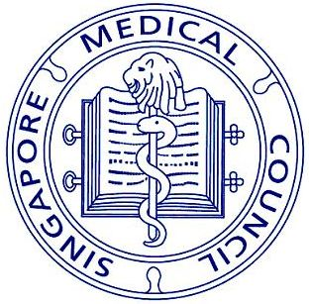
SINGAPORE MEDICAL COUNCIL
16 College Road, #01-01 College of Medicine Building, Singapore 169854
E-mail Address: SMC@spb.gov.sg
Website: http://www.smc.gov.sg
Fax Number: (65) 6221-0558

APPLICATION FORM TO PERFORM NON-LISTED AESTHETIC PROCEDURES

1. Personal Particulars of Doctor

Full Name:
MCR Number:
Registered Specialty:
Clinic’s Name:
Clinic’s Address:
Telephone Numbers: |  | (O) |  | (HP)
Email Address:

2. Information on Medical Malpractice Insurance

Note: It is recommended that doctors who have been performing aesthetic procedures or intend to do so have sufficient and appropriate medical malpractice insurance to safeguard patients’ interests.

Name of Insurance Provider:
Type of Insurance:
Start Date of Insurance:
Period of Insurance:
Premium Amount:

3. Name(s) of Non-Listed Aesthetic Procedure(s)

Note: Each procedure should be supported with the necessary regulatory approvals for the clinical trial and/or at least three key scientific papers in the English language.)

4. Declaration

I declare that the information provided in this application form is true and authentic and herein remains unchanged to-date. To the best of my knowledge and belief, I have not withheld any material fact. I understand that my practice may be audited and that I may be required to provide more information.

Signature and Name of Doctor Date

Please submit your application form and supporting documents to:
Chairman
Aesthetic Practice Oversight Committee
c/o Secretariat of Singapore Medical Council
16 College Road #01-01
College of Medicine Building
Singapore 169854

Alternatively, you may email to SMC@spb.gov.sg

