SINGAPORE MEDICAL COUNCIL
USEFUL INFORMATION ON
CONTINUING PROFESSIONAL EDUCATION (CPE) FOR PRACTISING
CERTIFICATE (PC) RENEWAL FOR DOCTORS
1) CPE REQUIREMENTS AND CORE POINTS REQUIREMENTS
- For the renewal of a 2-year PC, doctors will need to obtain at least 50 CPE points.
- Of the 50 CPE points, at least 10 must be core points in each of their registered specialty during their Qualifying Period (QP) and 5 must be core points in Mandatory Medical Ethics.
> For example, if a doctor is accredited as a specialist in Internal Medicine and Endocrinology, he/she has to accrue at least 10 points in Internal Medicine and 10 points in Endocrinology; and 5 core points in Mandatory Medical Ethics.
- Core and non-core CPE points are awarded based on SMC's accreditation of each activity and the doctor's registered specialty.
> For example, Cardiologists will earn core points for activities accredited by SMC as 'core' for Cardiology.
- QP is the period in which the doctors must accumulate sufficient CPE points to renew their PC and this period is the same as their PC validity.
2) CPE CATEGORIES AND CAPS ON CATEGORIES
- The table below shows the different categories of CPE activities and their respective caps for a 2-year PC:
Category | Description | Cap (2-year PC)
Cat 1A or Cat 1B | Local Events | No cap
Cat 1C | Overseas Events | No cap
Cat 2 | Publications | 40
Cat 3A | Self-study and Online Programmes | 10
Cat 3B | Distance Learning Programme | 36

- For Category 1B events, there is a cap of 4 CPE points per event per day.
- For Category 1B/1C events, there is an overall cap of 12 CPE points per event.
1

SINGAPORE MEDICAL COUNCIL

3) TO VIEW YOUR CPE REPORT
- Log in to the SMC website at www.smc.gov.sg with your SingPass and 2-factor verification.
- Once you have logged in, navigate through your account in the following order: “CPE” -> “Monitoring of CPE” -> “Detailed Report of Current QP” (as shown below)
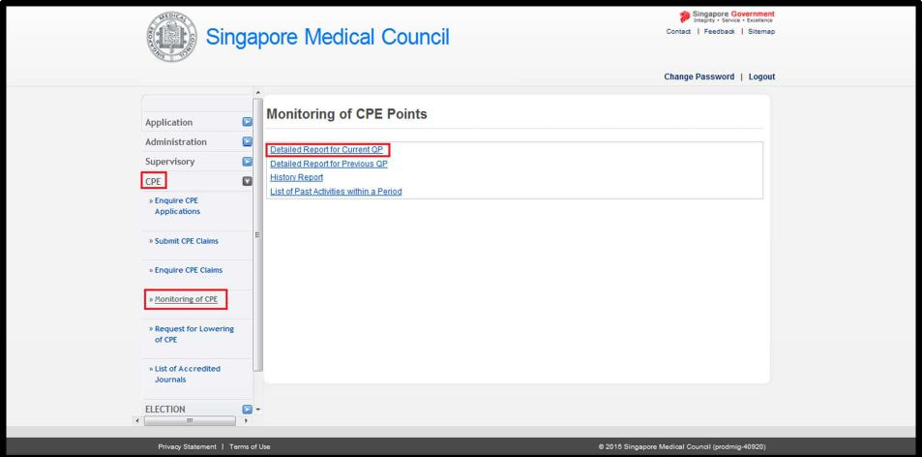
➢ You will be directed to the page to view your CPE report (as shown below).
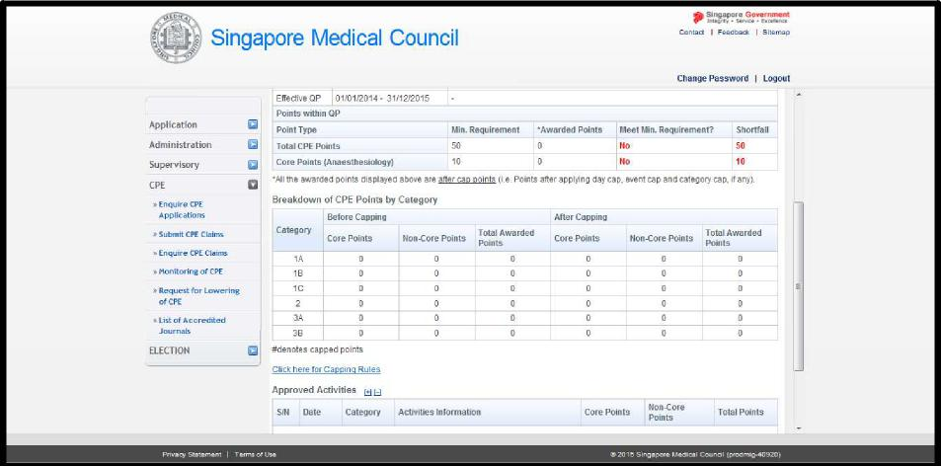
2

SINGAPORE MEDICAL COUNCIL

4) TO VIEW PAST CPE ACTIVITIES THAT ARE NOT IN THE CURRENT QP
- Once you have logged in, navigate through your account in the following order: “CPE” -> “Monitoring of CPE” -> “List of Past Activities within a Period” (as shown below).
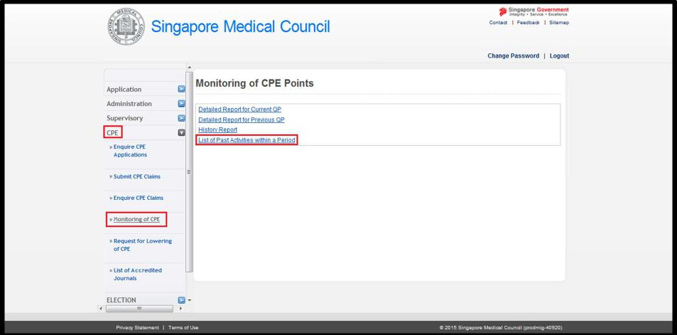
- Next, you will be directed to the page as shown below. Please key in the dates in the fields “Period From” and “To”. Then select “Generate”.
➢ For example, if you would like to check the activities you had participated two years preceding 1 June 2023 you can key in “From” as 02/06/2021 and “To” as 01/06/2023.
- You may view your CPE activities for any period as long as the maximum difference between “Period From” and “To” is 2 years.
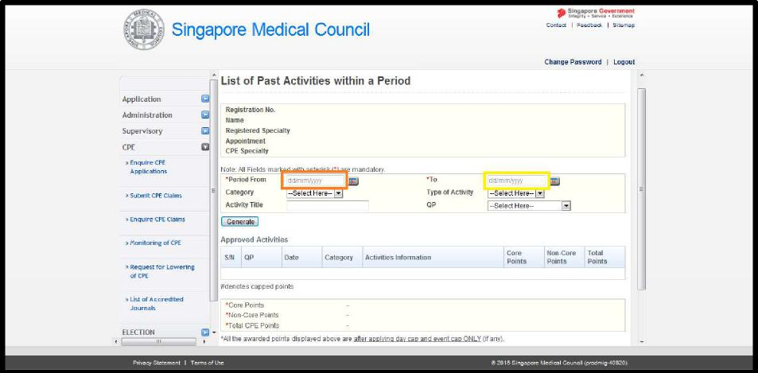
3

SINGAPORE MEDICAL COUNCIL
5) YOUR CPE REPORT DOES NOT SHOW YOUR POINTS CORRECTLY
- Your latest CPE points may not be updated because:
> CPE provider has not submitted the attendance records for local CPE events;
or
> SMC is still evaluating the self-claims which you have submitted.
- If there are any activities that are not updated in your CPE report, please note the activity title, activity ID, date and venue (for Cat 1 activities), and email to smc_cme@spb.gov.sg. We will help you to look into it.
- If there are any discrepancies, please email us a screenshot so that we can investigate the cause.
6) SUBMISSION OF CPE CLAIMS
- Under “CPE”, select “Submit CPE claims” and fill up the application form accordingly.
- You are required to fill up the sections marked with red asterisks (*).
- Please note that documentary proof in support of all claims (except Cat 3A) should be submitted to SMC.
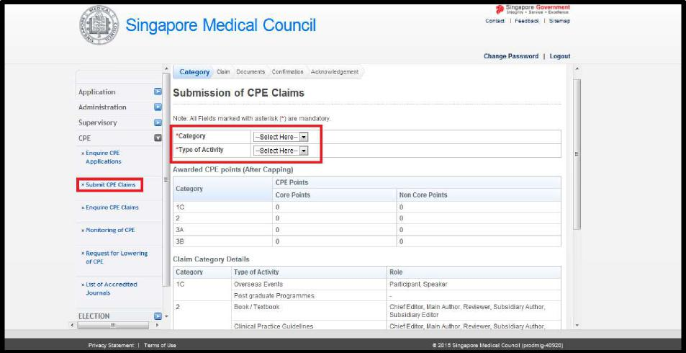
- Your claims may be rejected due to one of the following reasons:
> It is a local event. If you have attended any local events [Cat1A/1B] in Singapore, the organisers (CPE providers) will submit your attendance on your behalf. You only need to ensure that you have signed your attendance record for the event.
> You have attended an local online webinar. For this case, the organisers (CPE providers) will submit your attendance on your behalf.
> The event or organiser is not accredited by SMC.
4

SINGAPORE MEDICAL COUNCIL
7) SUPPORTING DOCUMENTS FOR CPE CLAIMS
- Please attach supporting documents when you submit Category 1C/2/3B claims to SMC.
- Examples of supporting documents may include:
> Cat 1C:
Programme details, Abstract, Poster, Certificate of Participation, Letter from Head
of Department in overseas hospitals
> Cat 2:
Abstract, Brochure, Poster, PowerPoint Slides, Certificate of Participation, any
other proof of your role as author/reviewer
> Cat 3B:
Certificate of Participation
- After completing the details of your CPE activity, you will be directed to the “Documents” section where you can upload supporting documents of your claim (as shown below).
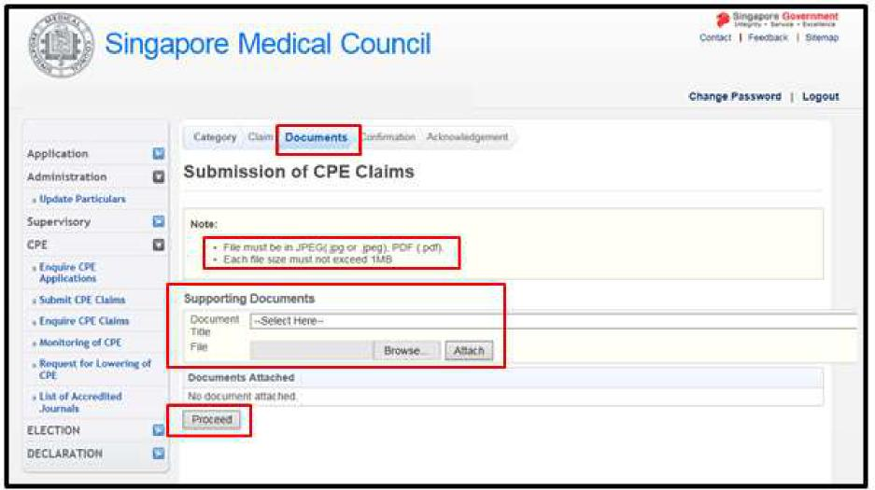
- Please note that you may only upload files which are:
> less than 1MB in size; and
> saved either in JPEG or PDF file format.
5

SINGAPORE MEDICAL COUNCIL

• To attach the supporting document, please do the following:
> Step 1: Select the most appropriate "Document Title" from the drop-down menu.
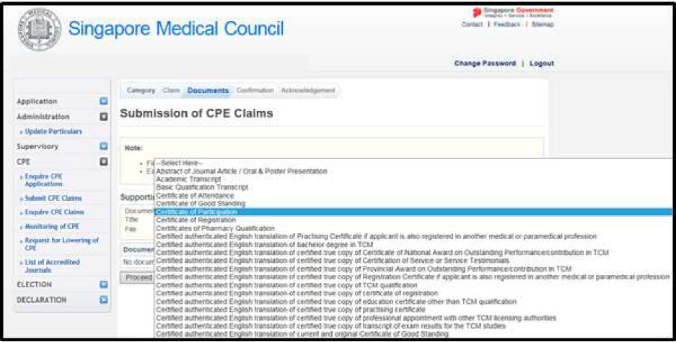
> Step 2: Choose the supporting document from your computer/laptop by clicking the "Browse" button (as shown below).
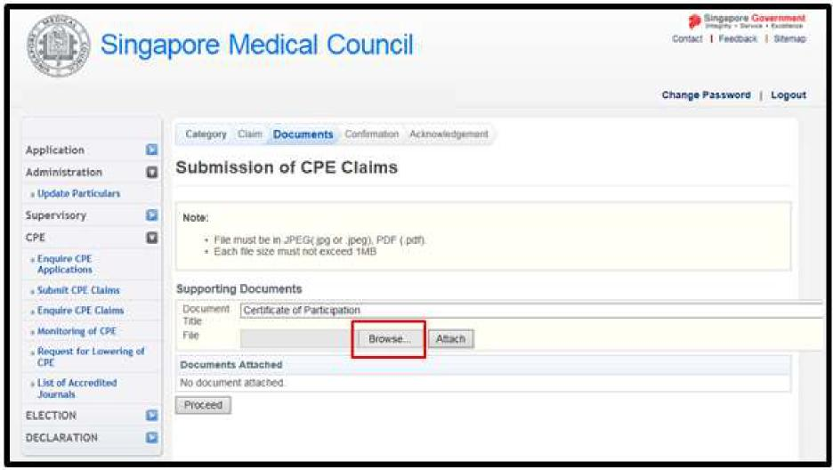
6

SINGAPORE MEDICAL COUNCIL

> Step 3: Once you have selected your supporting document, click "Open".
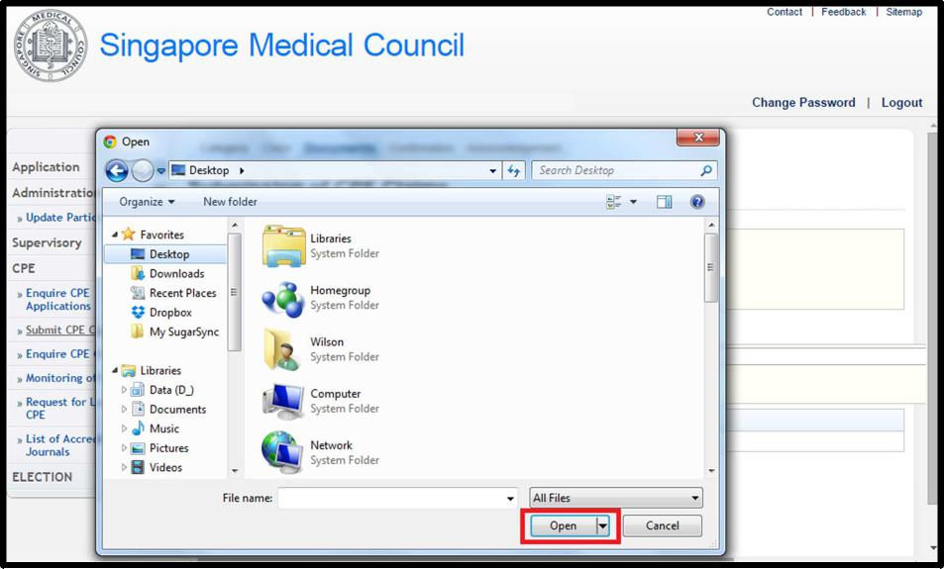
> Step 4: You should be directed to the previous screen. Click "Attach" to upload your supporting document.
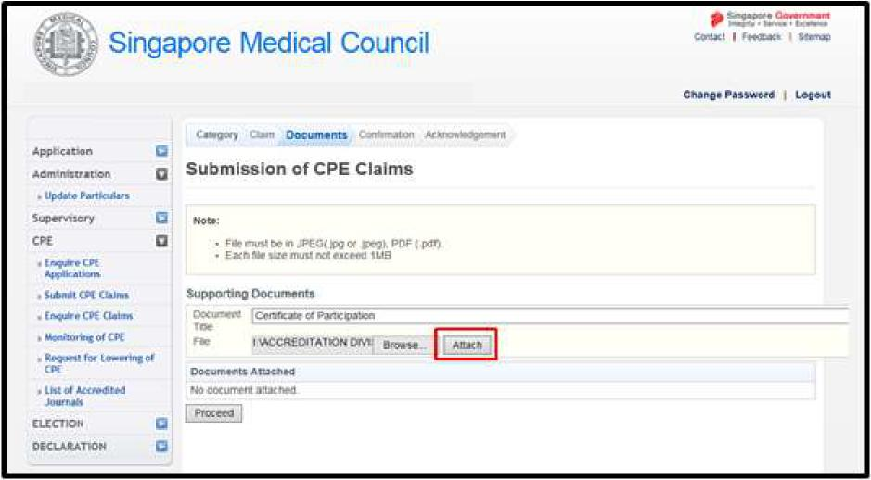
7

SINGAPORE MEDICAL COUNCIL

> Step 5: You should be able to see the screen below with the message "Upload successfully".
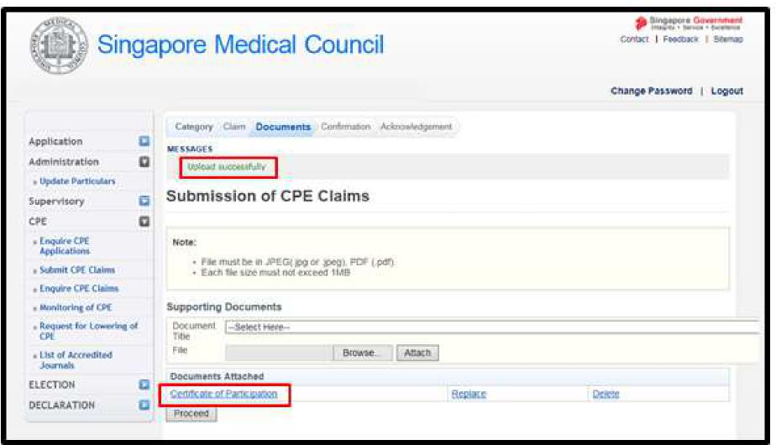
> You may choose to repeat the above mentioned procedure to upload additional supporting documents or click "Proceed" to continue the claim process.
8) EXEMPTION / PRO-RATION OF CPE REQUIREMENTS
- All doctors will need to fulfil their CPE requirements if they wish to renew their PC/apply for a new PC. There is no exemption or pro-ration of CPE points.
- If you have attended any event overseas, you may submit Category 1C claims online.
- For regular overseas department teaching sessions, please attach as supporting document, a letter from the Head of Department certifying your attendance. Please itemize the events by claim ID, Date, Topic and duration in the signed letter, for us to review the claims.

8

SINGAPORE MEDICAL COUNCIL

9) LOWER CPE REQUIREMENTS
- Lower CPE requirements are for doctors who are in reduced practice.
- Doctors in reduced practice:
> may prescribe medication for himself and his family members (spouse, child, adopted child, stepchild, grandchild, sibling, parent, step-parent and grandparent); and
> the above condition applies to doctors who are residing locally or overseas.
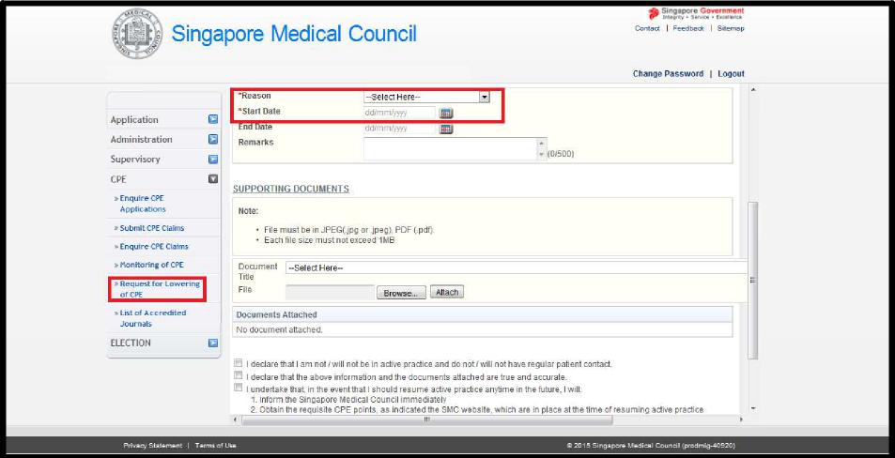
- Please note that your CPE requirements will be adjusted once the application is approved.
- The lower CPE requirements are:
> 10 CPE points for a 1-year PC; or
> 20 CPE points for a 2-years PC.

9

SINGAPORE MEDICAL COUNCIL

10) PC RENEWAL
- Your PC is not automatically renewed after you have met your CPE requirements.
- You will need to log in to the SMC website to submit an online PC renewal application.
- You may only apply for the renewal of your PC
> after you have met your CPE requirements; and
> do not have any outstanding fine for not voting in any SMC elections.
- If you have fulfilled the conditions in the preceding paragraph, you may log in to the SMC website to renew your PC from 2 September to 30 November.
- You may also submit your online PC renewal application in the month of December but a late application fee will be imposed.
11) CONTACT US
> For queries related to CPE, you may email us at smc_cme@spb.gov.sg
Date: January 2024

10

